Macbeth – Final Project
Mr. Jura’s English II Courses

Overview
Instead of doing an essay for your final project you will choose one project from the list below to show what you have learned about Shakespeare’s Macbeth. Each project in the list below is worth the same amount of points (200 points – Test Grade weight), which is the equivalent to 2 test grades per project.

Project Options
- Make your own soundtrack for Macbeth
- Create a movie poster to advertise a fictional film adaptation of the play
- Write a short creative short story (2000 words or less) that focuses on the central theme of Macbeth – the perils of unchecked ambition
- Create a YouTube video or Prezi presentation where you summarize and analyze the storyline of Macbeth
- Create a faux Instagram page for one of the characters in Macbeth

Grading
Each project type has its own rubric for grading (see attached). In order to receive full credit you must meet the criteria outlined in the rubric for the project you choose. Plagiarism will not be tolerated – you will receive a 0 on this project and a referral for academic dishonesty if you choose to use the work of someone else and attempt to present it as your own.

Extra Credit Points
All projects have built in “bonus point” options available. You will see the opportunities for bonus points as we review the project options.

Due Date
All projects are due on Friday, May 18th, 2015 – NO EXCEPTIONS! Only those with excused absences will be allowed to turn in projects after this due date.

Additional Information
Should you have additional questions or need to access this informational packet online you may visit the class website (www.mrjura.com) where you will find a PDF version of the packet. Or, as always, you may email me at aaron.jura@jppss.k12.la.us.

Project Option 1: Make your own soundtrack for Macbeth

You will need:
- 1 Blank CD and Case
- Music
- Pen and Paper
- Markers/Colored Pencils/Art Supplies

What you will produce:
- Create a soundtrack for Macbeth with at least 10 songs. You should have a minimum of 2 songs per act (5 acts x 2 songs = 10). Burn the songs to the CD in the order in which they would appear in the play.
- On a piece of paper, write down all titles and performers for each song, in the order they appear. Include a brief reason why each song fits into the play; this should be a total of two to three sentences. Include where the song fits into the play: give the act and scene numbers, and explain the action occurring when the song would be playing.
- Create a CD cover jacket that illustrates the play (in your eyes). This should be in color! Place this cover jacket into the case, just like you would find when buying a CD in the store.

Bonus Points:
You will be awarded 2 extra points for each song you include beyond the minimum of 10. These songs must be included on your title/reason sheet. Five extra songs is the limit, for a maximum of 10 extra points.

Project Option 2: Create a film movie poster for Macbeth

You will need:
- 1 piece of poster/chart paper
- Pen and Paper
- Markers/Colored Pencils/Art Supplies

Check out this website for a template for a movie poster: http://designspiration.net/image/3757909781875/

What you will produce:
- A movie poster advertising a film adaptation of the play Macbeth (make sure you include the items listed below on the example poster – also the poster should be illustrated (drawn, painted, decoupage – artist’s choice)
- On the back side of the poster you will write a 1 paragraph summary of why you included specific artistic elements on the front side of the poster

Bonus Points:
You will be awarded a maximum of 10 bonus points on the project based upon the inclusion of a quote of significance from the play and the quality and time put into the illustration and/or design of the poster. The bonus points will be awarded based upon the teacher’s judgement.

Movie Poster Template:
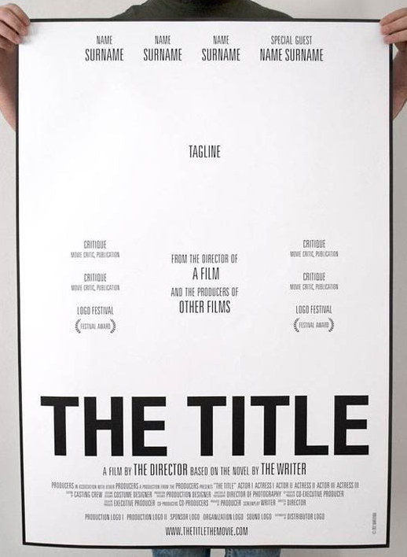

Project Option 3: Creative Short Story

You will need:
- Computer access
- Printer access (library printer available for .25 cents per page)

What you will produce:
- You will produce a creative short story of your own design based on the theme of Macbeth – the perils (dangers) of unchecked ambition
- Your creative short story must be cohesive (flow well) and well developed characters
- The story will be a maximum of 2,000 words, typed, and printed out as a hard copy. Soft (electronic copies) may be submitted via email or Edmodo

Bonus Points:
A maximum of 10 bonus points will be awarded based upon the overall character development of the piece. To earn bonus points you must use descriptive language to provide details on your characters. The bonus points will be awarded at the sole discretion of the teacher/grader.

Project Option 4: YouTube or Prezi Project

You will need:
- Computer/Internet Access
- Access to a video camera/smartphone with camera
- Microphone or recording device with sound

What you will produce:
- You will produce a YouTube Video or Prezi (prezi.com) presentation that summarizes Macbeth and provides a detailed analysis of the play itself
- The video must be uploaded to YouTube or Prezi in order to receive full credit for the project
- The presentation must include both a summary of the play and a detailed analysis of the play’s central theme of unchecked ambition / lust for power

Bonus Points:
A maximum of 10 bonus points will be awarded based upon the overall presentation quality. Remember that voice overs and videos should be recorded in a quiet space in order to receive the maximum amount of bonus points.

Project Option 5: Faux Instagram Page for a Macbeth character

You will need:
- Computer access
- Printer access (library printer available for .25 cents per page)
- Images for the Instagram feed
- An Instagram template (see Mr. Jura for a template)

What you will produce:
- You will produce a faux (fake) Instagram page for a selected character from the play Macbeth
- You must include images that the character would share on their feed and comments from other characters in reply to the images posted (followers/haters/etc.)
- You will be required to print out the images (or cut them from magazines) and turn them in attached to a Instagram template to receive full credit

Bonus Points:
A maximum of 10 bonus points will be awarded based upon the overall quality of the images selected and the comments made by the characters in response. These bonus points will be awarded at the sole discretion of the teacher/grader.

